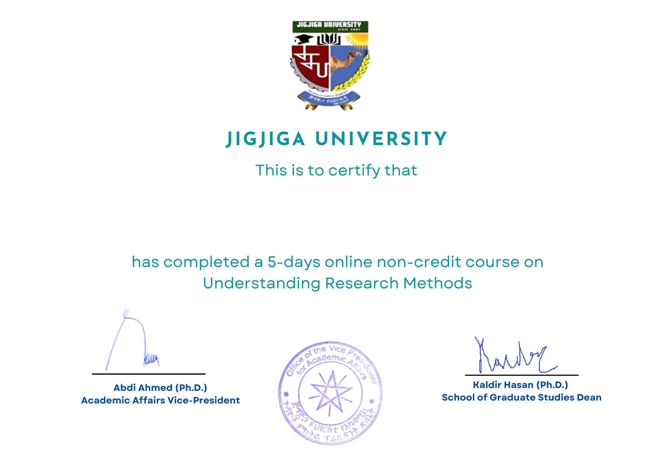

**MAHAMED ALI JAMA**